Engineering Electromagnetics Lab 2

Yanning He (何衍宁), 12311512

Abstract—This document provides a guide for preparing articles for IEEE Transactions, Journals, and Letters. Use this document as a template if you are using Microsoft Word. Otherwise, use this as an instruction set. The electronic file of your article will be formatted further at IEEE. Titles should be written in uppercase and lowercase letters, not all uppercase. Avoid writing long formulas with subscripts in the title; short formulas that identify the elements are fine (e.g., "Nd–Fe–B"). Do not write “(Invited)” in the title. Full names of authors are preferred in the author field but are not required. Put a space between authors’ initials. ORCIDs can be provided here as well. In the title, all variables should appear lightface italic; numbers and units will remain bold. Abstracts must be a single paragraph. In order for an Abstract to be effective when displayed in IEEE Xplore as well as through indexing services such as Compendex, INSPEC, Medline, ProQuest, and Web of Science, it must be an accurate, stand-alone reflection of the contents of the article. They shall not contain displayed mathematical equations, numbered reference citations, nor footnotes. They should include three or four different keywords or phrases, as this will help readers to find it. It is important to avoid over-repetition of such phrases as this can result in a page being rejected by search engines. Ensure that your abstract reads well and is grammatically correct.

Index Terms—Enter keywords or phrases in alphabetical order, separated by commas. Using the IEEE Thesaurus can help you find the best standardized keywords to fit your article. Use the thesaurus access request form for free access to the IEEE Thesaurus https://www.ieee.org/publications/services/thesaurus.html.

I. INTRODUCTION
T
he objectives of this experiment are to achieve proficiency in using Matlab for calculating the electric field distribution of linear charges and generating the corresponding graphical representations, while developing a deeper conceptual understanding of the method of infinitesimals and the principles of calculus through practical application.

II.PRINCIPLE
The electric field intensity $E$ produced by a point charge in a vacuum is given by:
$$E=k\frac{Q}{R^{2}}\hat{r} \left(1\right)$$
where the coefficient $k=9×{10}^{9} \text{N}⋅{\text{m}}^{2}/{\text{C}}^{2}$ is the electrostatic constant, $Q$ represents the quantity of the point charge, and $R$ is the distance from the point charge to the field point.
If the potential at infinity is taken as the zero reference point, the electric potential $Φ$ generated by a point charge in a vacuum is:
$$Φ=k\frac{Q}{R} \left(2\right)$$
The electric field intensity can also be expressed as the negative gradient of the electric potential:
$$E=-∇Φ \left(3\right)$$
The total electric potential generated by $N$ point charges in a vacuum is the algebraic sum:
$$Φ=\sum_{i=1}^{N}{k}\frac{Q_{i}}{R_{i}} \left(4\right)$$
Similarly, the total electric field intensity generated by $N$ point charges can be derived using Equation (3).
When the field source is a continuously distributed charge, such as a linear charge, we can employ the method of infinitesimals (element-based method) or calculus to solve the problem. The specific steps for the method of infinitesimals are as follows:
1 Segmentation: Divide the linear charge into $N$ small segments (typically using a uniform subdivision).
2 Point Charge Approximation: Treat each small segment as a point charge and use Equation (2) to calculate the potential it generates in space.
3 Superposition: Apply Equation (4) to sum the potentials of all segments, obtaining the total potential of the entire linear charge.
4 Field Calculation: Use Equation (3) to determine the total electric field intensity.
Results obtained via the method of infinitesimals inherently contain numerical errors. This error primarily depends on the number of segments defined in Step 1; generally, a higher number of segments leads to a smaller error. For certain geometries, the exact electric field distribution can be solved analytically using calculus. This allows for a comparative study of the relationship between the discretization error and the number of segments used.
Fig. 1. This is a sample of a figure caption.

III. CONTENTS
Objective: Use Matlab to analyze the electrostatic field distribution of a linear charge in a 2D Cartesian coordinate system.
Parameters: A linear charge with a density of $ρ=1×{10}^{-9} \text{C}\text{/}\text{m}$ is distributed along the line segment between point A(-1, 0) and point B(1, 0). (All coordinates are in meters).

TABLE I
This is a Sample of a Table Title

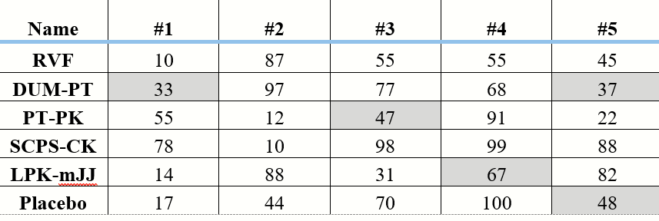

A. Analytical Solution (The "True" Distribution)
Using the method of calculus, calculate the theoretical electric potential distribution at any point $\left(X_{0},Y_{0}\right)$ in the 2D plane. The derivation process is as follows:
- Differential Element: Let an infinitesimal charge element $dQ = ρ dx$ be located at $\left(x,0\right)$ on the x-axis, where $x∈\left[-1,1\right]$.
- Distance: The distance $R$ from the element to the field point $\left(X_{0},Y_{0}\right)$ is:
$$R=\sqrt{{\left(X_{0}-x\right)}^{2}+Y_{0}^{2}}$$
- Integral Setup: The potential $d\Phi$ generated by this element is $dΦ=\frac{kρ dx}{\sqrt{{\left(X_{0}-x\right)}^{2}+Y_{0}^{2}}}$.
- Total Potential: Integrating from $x = -1$ to $x = 1$:
$$Φ\left(X_{0},Y_{0}\right)=\int_{-1}^{1}{\frac{kρ}{\sqrt{{\left(X_{0}-x\right)}^{2}+Y_{0}^{2}}}}dx$$
Task: Select an appropriate field domain. Based on the analytical result above, develop a Matlab program to calculate and plot the following within the domain:
- 3D surface plot of the electric potential distribution.
- Equipotential contour lines (select appropriate intervals).
- Electric field lines (represented by smooth, continuous curves).

B. Numerical Solution (Method of Infinitesimals)
Using the method of infinitesimals, divide the linear charge into 20, 50, and 100 segments, respectively. Using the same field domain as Step 1, use Matlab to calculate and plot:
- The potential distribution, equipotential lines, and electric field lines for each discretization level.

C. Quantitative Error Analysis
Quantitatively compare the results obtained from the method of infinitesimals against the analytical "true" values. Conduct a study on the relationship between the calculation error and the number of segments ($N$) used in the discretization.

IV. CODE and EXPERIMENT

A. Code 1: Continuous Line Charge Simulation
clc; clear; close all;

%% 1. Parameter Initialization & Domain Setup
k = 9e9; % Electrostatic constant (N·m^2/C^2)
p = 1e-9; % Linear charge density (C/m)
xm = 2; ym = 2; % Define observation domain boundaries (meters)

% Generate calculation grid for the 2D plane
% Increasing resolution to 200 for smoother gradient transitions
x = linspace(-xm, xm, 200);
y = linspace(-ym, ym, 200);
[X, Y] = meshgrid(x, y);

%% 2. Analytical Solution (Integral Method)
% Based on the integral formula: V = k*p * ln[ (r1) / (r2) ]
% where the integration is performed along the segment x' = [-1, 1]
r1 = 1 - X + sqrt((1 - X).^2 + Y.^2);
r2 = -1 - X + sqrt((-1 - X).^2 + Y.^2);
V = k .* p .* log(r1 ./ r2);

%% 3. Plotting 3D Potential Distribution
figure('Color', 'w'); % Set background to white for report compatibility
mesh(X, Y, V);
colormap jet; % Apply heat-map color scheme
colorbar;
grid on;
xlabel('X-axis (m)'); ylabel('Y-axis (m)'); zlabel('Potential V (V)');
% Title formatted as a cell array for multi-line display
title({'Potential Distribution of Line Charge (Analytical)', ...
'Author: Yanning He, ID: 12311512'});
saveas(gcf, 'figure1.1.jpg');

%% 4. Plotting Equipotential Contours
figure('Color', 'w');
V_levels = linspace(0, 100, 50); % Define contour density
[C, h] = contour(X, Y, V, V_levels, 'LineWidth', 1);
colorbar;
hold on;

% Highlight the linear charge source (Red solid line)
plot([-1, 1], [0, 0], 'r', 'LineWidth', 3);
grid on;
axis equal; % Maintain 1:1 aspect ratio to avoid spatial distortion
xlabel('X-axis (m)'); ylabel('Y-axis (m)');
title({'Equipotential Contours (Analytical Method)', ...
'Author: Yanning He, ID: 12311512'});
saveas(gcf, 'figure1.2.jpg');

%% 5. Plotting Composite Map (Electric Field Lines & Potential)
% Calculate electric field intensity E = -grad(V)
[Ex, Ey] = gradient(-V);

figure('Color', 'w');
hold on;
colorbar;

% Define seed points for streamlines to ensure uniform distribution
xs_seed = -1.2:0.2:1.2;
ys_seed_pos = 0.05 * ones(size(xs_seed));
ys_seed_neg = -0.05 * ones(size(xs_seed));

% Generate streamlines to represent the electric field
h1 = streamline(X, Y, Ex, Ey, xs_seed, ys_seed_pos);
h2 = streamline(X, Y, Ex, Ey, xs_seed, ys_seed_neg);
set([h1, h2], 'LineWidth', 2, 'Color', [0.1, 0.4, 0.1]);

% Overlay contours and the physical charge location
contour(X, Y, V, V_levels, 'LineColor', 'b');
plot([-1, 1], [0, 0], 'r', 'LineWidth', 4);

grid on;
axis equal; % Critical for preserving orthogonality of E and V lines
xlabel('X-axis (m)'); ylabel('Y-axis (m)');
title({'Electric Field Lines & Equipotential Mapping', ...
'Author: Yanning He, ID: 12311512'});
saveas(gcf, 'figure1.3.jpg');
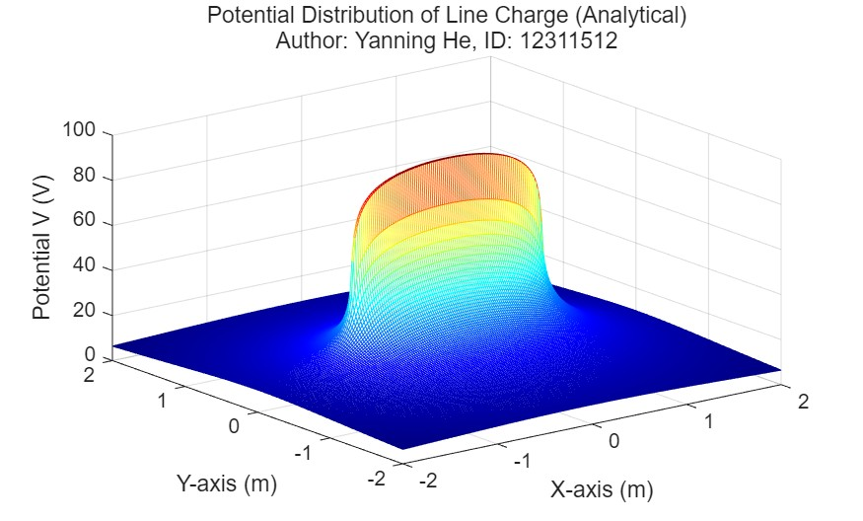
Fig. 1.1. Potential Distribution of Line Charge (Analytical)

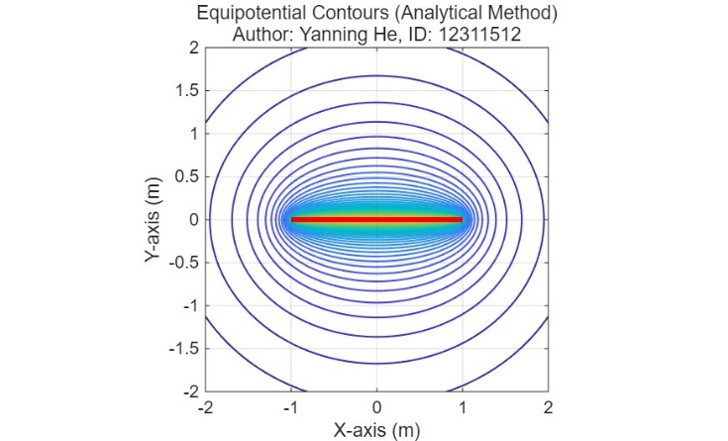
Fig. 1.2. Equipotential Contours (Analytical Method)
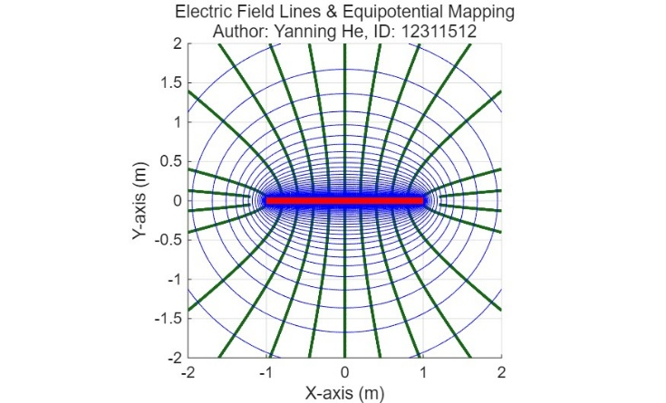
Fig. 1.3. Electric Field Lines & Equipotential Mapping

B. Code 2: Segmented charge simulation of 20, 50, 100
N=20
clc; clear; close all;

%% 1. Parameter Initialization & Discretization Setup
k = 9e9; % Electrostatic constant (N·m^2/C^2)
p = 1e-9; % Linear charge density (C/m)
L_total = 2; % Total length of the charge (from -1 to 1)
N = 20; % Number of segments (Change to 50 or 100 for other tasks)
dL = L_total / N; % Length of each infinitesimal element
dQ = p * dL; % Charge of each infinitesimal element

% Observation domain setup
xm = 2; ym = 2;
x = linspace(-xm, xm, 100);
y = linspace(-ym, ym, 100);
[X, Y] = meshgrid(x, y);

%% 2. Method of Infinitesimals (Numerical Summation)
V = zeros(size(X)); % Initialize potential matrix
for i = 1:N
% Calculate the center position of each segment
% Start at -1, offset by half a segment, then increment by dL
x_pos = -1 + (i - 0.5) * dL;

% Distance from the segment center to all grid points
R = sqrt((X - x_pos).^2 + Y.^2);

% Superposition of potential: V = sum( k * dQ / R )
V = V + (k * dQ ./ R);
end

%% 3. Plotting 3D Potential Distribution
figure('Color', 'w');
mesh(X, Y, V);
colormap jet;
grid on;
xlabel('X-axis (m)'); ylabel('Y-axis (m)'); zlabel('Potential V (V)');
title({['Potential Distribution (Method of Infinitesimals, N=', num2str(N), ')'], ...
'Author: Yanning He, ID: 12311512'}, 'FontSize', 12);
saveas(gcf, 'figure2.1.jpg');

%% 4. Plotting Equipotential Contours
figure('Color', 'w');
V_levels = linspace(0, 100, 101); % Contour levels from 0V to 100V
contour(X, Y, V, V_levels);
hold on;
plot([-1, 1], [0, 0], 'r', 'LineWidth', 3); % Represent the physical line charge
grid on;
axis equal;
xlabel('X-axis (m)'); ylabel('Y-axis (m)');
title({['Equipotential Lines (Method of Infinitesimals, N=', num2str(N), ')'], ...
'Author: Yanning He, ID: 12311512'}, 'FontSize', 12);
saveas(gcf, 'figure2.2.jpg');

%% 5. Plotting Electric Field Lines
[Ex, Ey] = gradient(-V); % E-field is the negative gradient of potential
xs_seed = -1.2:0.1:1.2; % Starting points for streamlines
ys_seed_pos = 0.05 * ones(size(xs_seed));
ys_seed_neg = -0.05 * ones(size(xs_seed));

figure('Color', 'w');
hold on;
% Draw streamlines representing the direction of the electric field
h1 = streamline(X, Y, Ex, Ey, xs_seed, ys_seed_pos);
h2 = streamline(X, Y, Ex, Ey, xs_seed, ys_seed_neg);
set([h1, h2], 'LineWidth', 1.5, 'Color', [0.1, 0.4, 0.1]);

contour(X, Y, V, V_levels); % Overlay equipotential lines
plot([-1, 1], [0, 0], 'r', 'LineWidth', 3);
grid on;
axis equal;
xlabel('X-axis (m)'); ylabel('Y-axis (m)');
title({['Electric Field Lines (Method of Infinitesimals, N=', num2str(N), ')'], ...
'Author: Yanning He, ID: 12311512'}, 12);
saveas(gcf, 'figure2.3.jpg');
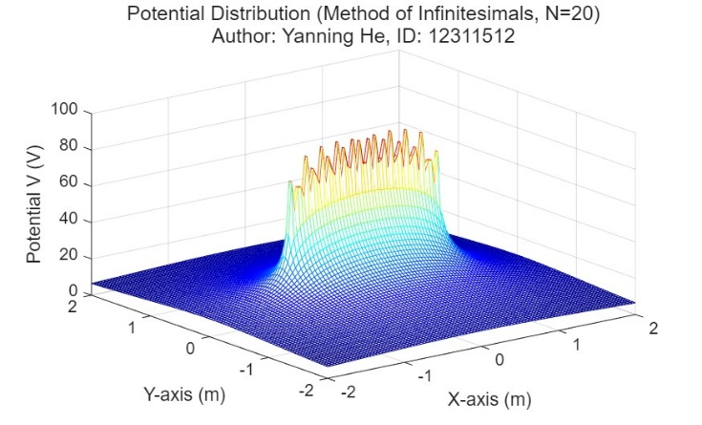
Fig. 1.3. Electric Field Lines & Equipotential Mapping
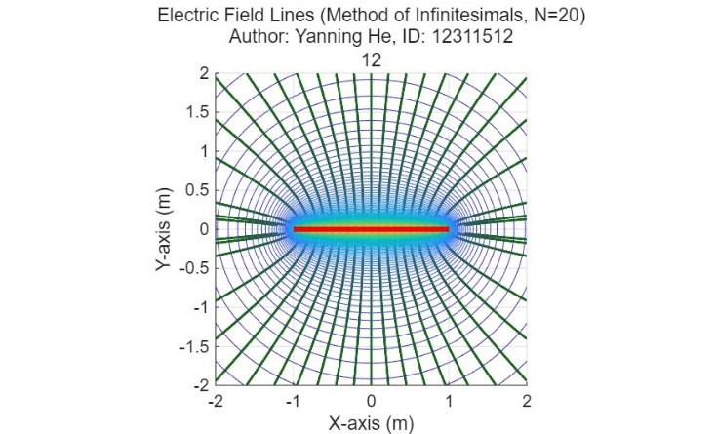

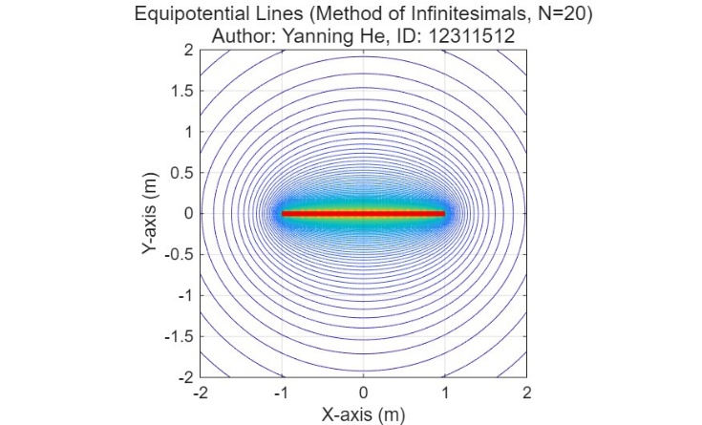

N=50
clc; clear; close all;

%% 1. Parameter Initialization & Discretization Setup
k = 9e9; % Electrostatic constant (N·m^2/C^2)
p = 1e-9; % Linear charge density (C/m)
L_total = 2; % Total length of the charge (from -1 to 1)
N = 50; % Number of segments (Change to 50 or 100 for other tasks)
dL = L_total / N; % Length of each infinitesimal element
dQ = p * dL; % Charge of each infinitesimal element

% Observation domain setup
xm = 2; ym = 2;
x = linspace(-xm, xm, 100);
y = linspace(-ym, ym, 100);
[X, Y] = meshgrid(x, y);

%% 2. Method of Infinitesimals (Numerical Summation)
V = zeros(size(X)); % Initialize potential matrix
for i = 1:N
% Calculate the center position of each segment
% Start at -1, offset by half a segment, then increment by dL
x_pos = -1 + (i - 0.5) * dL;

% Distance from the segment center to all grid points
R = sqrt((X - x_pos).^2 + Y.^2);

% Superposition of potential: V = sum( k * dQ / R )
V = V + (k * dQ ./ R);
end

%% 3. Plotting 3D Potential Distribution
figure('Color', 'w');
mesh(X, Y, V);
colormap jet;
grid on;
xlabel('X-axis (m)'); ylabel('Y-axis (m)'); zlabel('Potential V (V)');
title({['Potential Distribution (Method of Infinitesimals, N=', num2str(N), ')'], ...
'Author: Yanning He, ID: 12311512'}, 'FontSize', 12);
saveas(gcf, 'figure3.1.jpg');

%% 4. Plotting Equipotential Contours
figure('Color', 'w');
V_levels = linspace(0, 100, 101); % Contour levels from 0V to 100V
contour(X, Y, V, V_levels);
hold on;
plot([-1, 1], [0, 0], 'r', 'LineWidth', 3); % Represent the physical line charge
grid on;
axis equal;
xlabel('X-axis (m)'); ylabel('Y-axis (m)');
title({['Equipotential Lines (Method of Infinitesimals, N=', num2str(N), ')'], ...
'Author: Yanning He, ID: 12311512'}, 'FontSize', 12);
saveas(gcf, 'figure3.2.jpg');

%% 5. Plotting Electric Field Lines
[Ex, Ey] = gradient(-V); % E-field is the negative gradient of potential
xs_seed = -1.2:0.1:1.2; % Starting points for streamlines
ys_seed_pos = 0.05 * ones(size(xs_seed));
ys_seed_neg = -0.05 * ones(size(xs_seed));

figure('Color', 'w');
hold on;
% Draw streamlines representing the direction of the electric field
h1 = streamline(X, Y, Ex, Ey, xs_seed, ys_seed_pos);
h2 = streamline(X, Y, Ex, Ey, xs_seed, ys_seed_neg);
set([h1, h2], 'LineWidth', 1.5, 'Color', [0.1, 0.4, 0.1]);

contour(X, Y, V, V_levels); % Overlay equipotential lines
plot([-1, 1], [0, 0], 'r', 'LineWidth', 3);
grid on;
axis equal;
xlabel('X-axis (m)'); ylabel('Y-axis (m)');
title({['Electric Field Lines (Method of Infinitesimals, N=', num2str(N), ')'], ...
'Author: Yanning He, ID: 12311512'}, 12);
saveas(gcf, 'figure3.3.jpg');

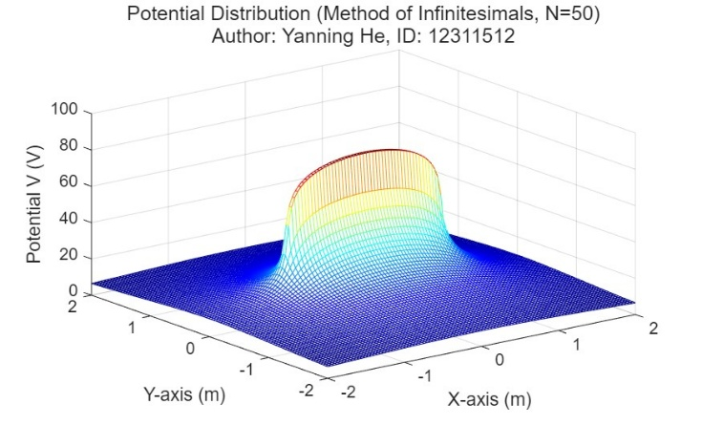

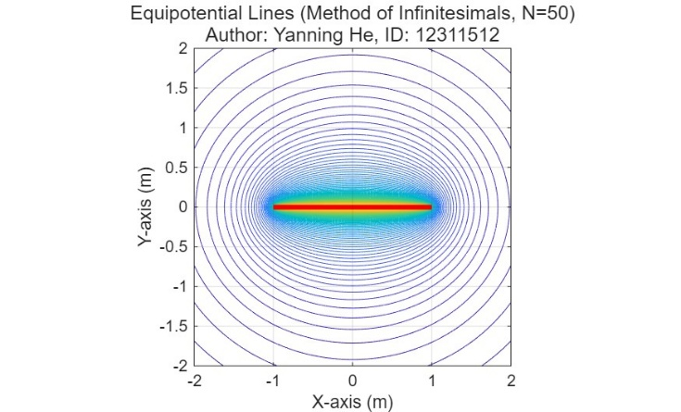

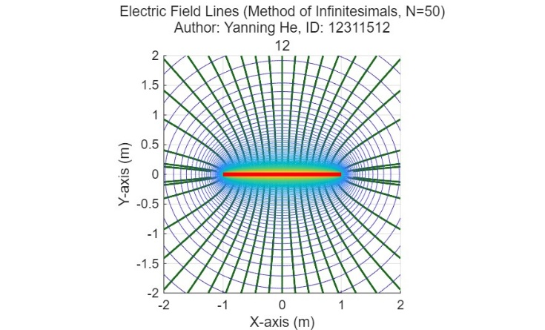

N=100
clc; clear; close all;

%% 1. Parameter Initialization & Discretization Setup
k = 9e9; % Electrostatic constant (N·m^2/C^2)
p = 1e-9; % Linear charge density (C/m)
L_total = 2; % Total length of the charge (from -1 to 1)
N = 100; % Number of segments (Change to 50 or 100 for other tasks)
dL = L_total / N; % Length of each infinitesimal element
dQ = p * dL; % Charge of each infinitesimal element

% Observation domain setup
xm = 2; ym = 2;
x = linspace(-xm, xm, 100);
y = linspace(-ym, ym, 100);
[X, Y] = meshgrid(x, y);

%% 2. Method of Infinitesimals (Numerical Summation)
V = zeros(size(X)); % Initialize potential matrix
for i = 1:N
% Calculate the center position of each segment
% Start at -1, offset by half a segment, then increment by dL
x_pos = -1 + (i - 0.5) * dL;

% Distance from the segment center to all grid points
R = sqrt((X - x_pos).^2 + Y.^2);

% Superposition of potential: V = sum( k * dQ / R )
V = V + (k * dQ ./ R);
end

%% 3. Plotting 3D Potential Distribution
figure('Color', 'w');
mesh(X, Y, V);
colormap jet;
grid on;
xlabel('X-axis (m)'); ylabel('Y-axis (m)'); zlabel('Potential V (V)');
title({['Potential Distribution (Method of Infinitesimals, N=', num2str(N), ')'], ...
'Author: Yanning He, ID: 12311512'}, 'FontSize', 12);
saveas(gcf, 'figure4.1.jpg');

%% 4. Plotting Equipotential Contours
figure('Color', 'w');
V_levels = linspace(0, 100, 101); % Contour levels from 0V to 100V
contour(X, Y, V, V_levels);
hold on;
plot([-1, 1], [0, 0], 'r', 'LineWidth', 3); % Represent the physical line charge
grid on;
axis equal;
xlabel('X-axis (m)'); ylabel('Y-axis (m)');
title({['Equipotential Lines (Method of Infinitesimals, N=', num2str(N), ')'], ...
'Author: Yanning He, ID: 12311512'}, 'FontSize', 12);
saveas(gcf, 'figure4.2.jpg');

%% 5. Plotting Electric Field Lines
[Ex, Ey] = gradient(-V); % E-field is the negative gradient of potential
xs_seed = -1.2:0.1:1.2; % Starting points for streamlines
ys_seed_pos = 0.05 * ones(size(xs_seed));
ys_seed_neg = -0.05 * ones(size(xs_seed));

figure('Color', 'w');
hold on;
% Draw streamlines representing the direction of the electric field
h1 = streamline(X, Y, Ex, Ey, xs_seed, ys_seed_pos);
h2 = streamline(X, Y, Ex, Ey, xs_seed, ys_seed_neg);
set([h1, h2], 'LineWidth', 1.5, 'Color', [0.1, 0.4, 0.1]);

contour(X, Y, V, V_levels); % Overlay equipotential lines
plot([-1, 1], [0, 0], 'r', 'LineWidth', 3);
grid on;
axis equal;
xlabel('X-axis (m)'); ylabel('Y-axis (m)');
title({['Electric Field Lines (Method of Infinitesimals, N=', num2str(N), ')'], ...
'Author: Yanning He, ID: 12311512'}, 12);
saveas(gcf, 'figure4.3.jpg');

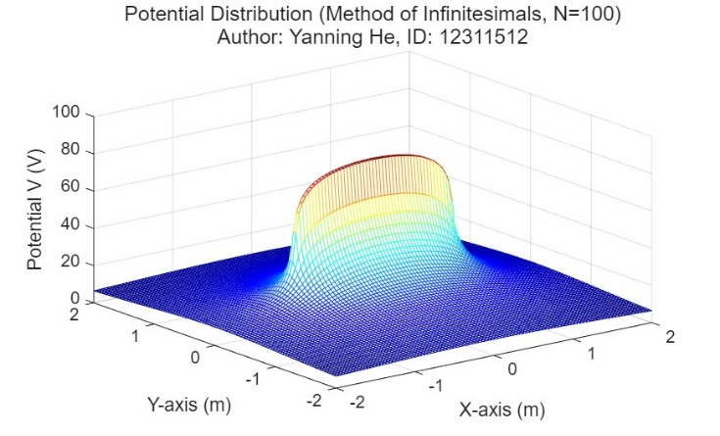

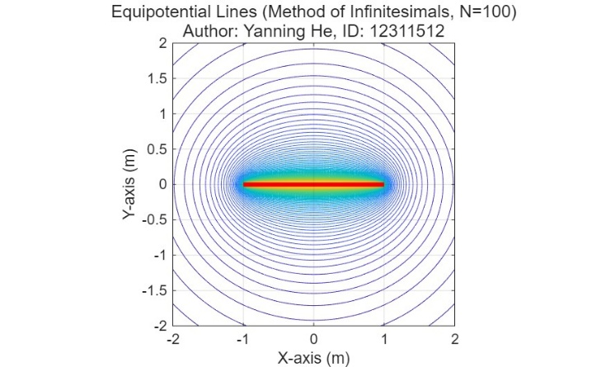

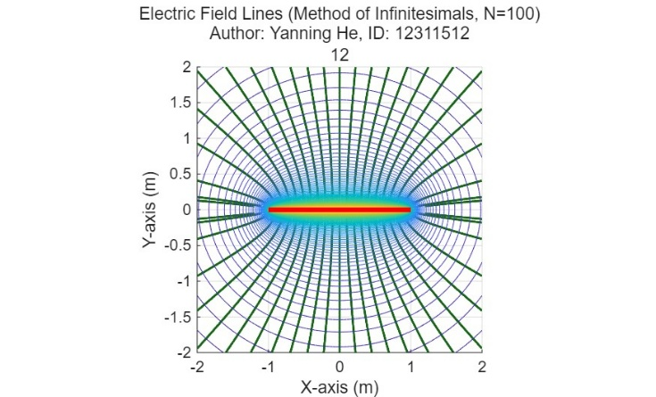

C. File Formats for Graphics
F

D. Sizing of Graphics
M

E. Resolution
T

F. Vector Art
I

G. Color Space
T

H. Accepted Fonts Within Figures
W

J. Referencing a Figure or Table Within Your Article
W

K. Submitting Your Graphics
B

L. Color Processing / Printing in IEEE Transactions, Journals, and Letters
A
V. Conclusion
A conclusion section is not required. Although a conclusion may review the main points of the article, do not replicate the abstract as the conclusion. A conclusion might elaborate on the importance of the work or suggest applications and extensions.

